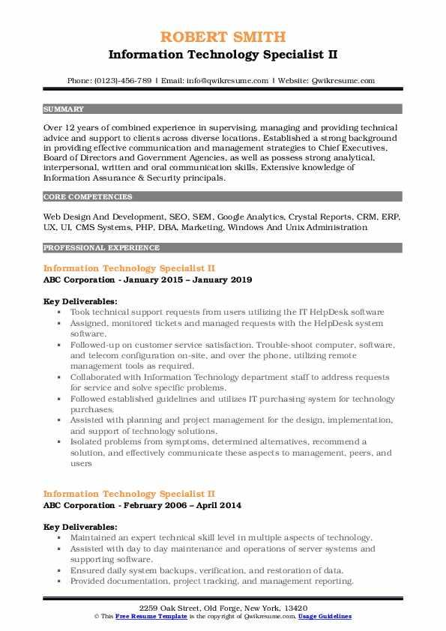
ROBERT SMITH
Information Technology Specialist II
Phone: (0123)-456-789 | Email: info@qwikresume.com | Website: Qwikresume.com
SUMMARY
Over 12 years of combined experience in supervising managing and providing technical advice and support to clients across diverse locations. Established a strong background in providing effective communication and management strategies to Chief Executives. Board of Directors and Government Agencies, as well as possess strong analytical. interpersonal, written and oral communication skills. Extensive knowledge of Information Assurance & Security principals.
CORE COMPETENCIES
Web Design And Development, SEO, SEM, Google Analytics, Crystal Reports, CRM, ERP. UX, UI. CMS Systems, PHP, DBA, Marketing. Windows And Unix Administration
PROFESSIONAL EXPERIENCE
Information Technology Specialist II
ABC Corporation - January 2015 January 2019
Key Deliverables:
Took technical support requests from users utilizing the IT HelpDesk software ⚫ Assigned, monitored tickets and managed requests with the HelpDesk system software.
Followed-up on customer service satisfaction. Trouble-shoot computer, software. and telecom configuration on-site, and over the phone, utilizing remote management tools as required.
• Collaborated with Information Technology department staff to address requests for service and solve specific problems.
■ Followed established guidelines and utilizes IT purchasing system for technology purchases:
⚫ Assisted with planning and project management for the design, implementation, and support of technology solutions.
⚫ Isolated problems from symptoms, determined alternatives, recommend a
solution, and effectively communicate these aspects to management, peers, and users
Information Technology Specialist II
ABC Corporation - February 2006 - April 2014
Key Deliverables:
Maintained an expert technical skill level in multiple aspects of technology. ■ Assisted with day to day maintenance and operations of server systems and supporting software.
• Ensured daily system backups, verification, and restoration of data. Provided documentation, project tracking, and management reporting
2259 Oak Street, Old Forge, New York, 13420
© This Free Resume Template is the copyright of Quikresume.com, Usage Guidelines

